FLAGSTAFF
As everyone knows, Flagstaff is centrally located among the Four Corners states and is the Gateway to the Grand Canyon. It is nestled at the foothills of the San Francisco Peaks which tower over 13,000 feet. Of course, there is also Sedona nearby with the beautiful red rock cliffs. You wouldn’t want to miss a visit to the Lowell Observatory, Meteor Crater, the hopping Downtown Flagstaff at the square, or simply park yourself at one of the many microbreweries Flagstaff is known for.
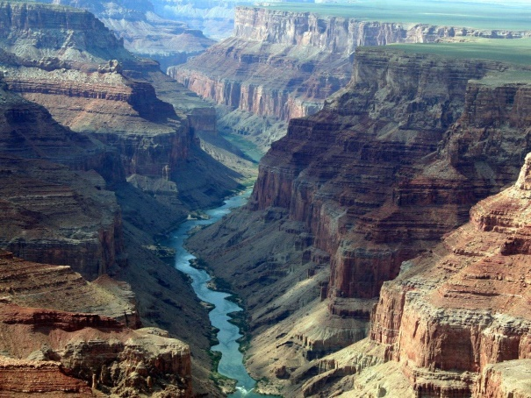 | 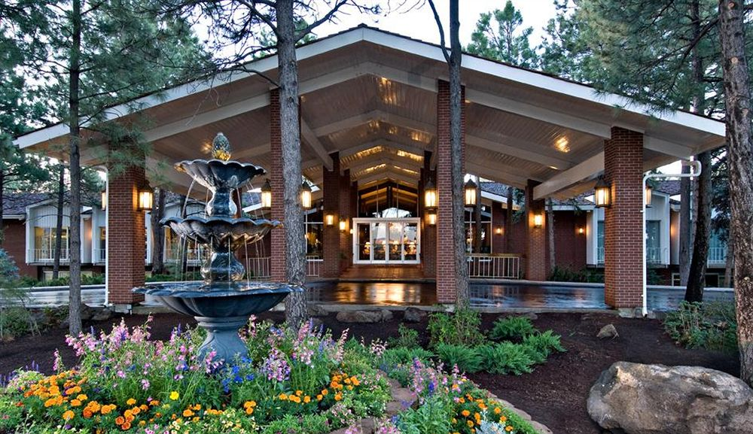

PHOENIX/SCOTTSDALE
Arizona has some of the most amazing sunsets!
We also offer fabulous hiking trails, shopping, golfing, gambling, and amazing spas!
Take some extra time and enjoy a Jeep tour of the desert, go horseback riding, or in less than two hours enjoy the gorgeous red rocks of Sedona.
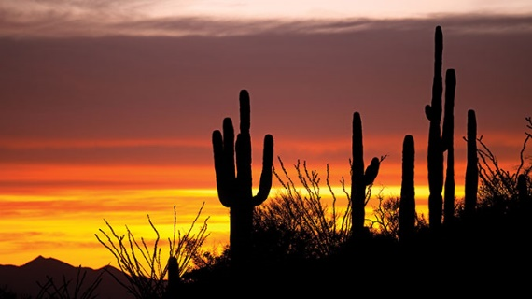

SANTA FE/ALBUQUERQUE
Visit Santa Fe, New Mexico - The City Different. Santa Fe, New Mexico is a magical, exuberant, colorful journey at any time of year. Our legendary history and culture will fascinate and inspire you. Our art galleries and diverse visual arts span ancient traditional art to the most contemporary, making it one of the largest and most important art markets in the country. Settle yourself into our World Class accommodations, partake of our sumptuous world-renowned cuisine and treat yourself to our colorful markets and experience why Santa Fe has been considered a legendary trading center for hundreds of years.
Less than an hour's drive from Albuquerque or fly directly to Santa Fe from Denver, Phoenix, or Dallas. To learn more, check out https://santafe.org
Albuquerque is only 57 miles from Santa Fe, New Mexico. Come enjoy our beautiful International Balloon Fiesta. See the skies light up with our beautiful hot air balloons. Also, we have night glows that light up the beautiful evenings.
To learn more, check out http://www.balloonfiesta.com
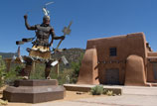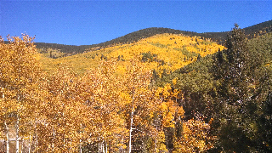
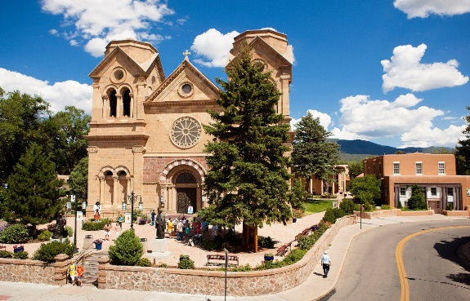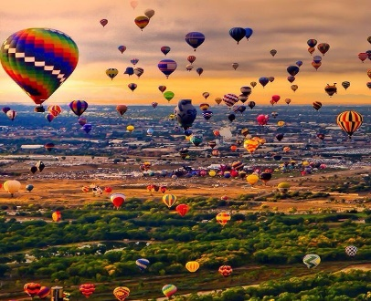

COLORADO SPRINGS
Some things to do and see in and around Colorado Springs are Pikes Peak, Red Rocks Amphitheater, Garden of the Gods, Manitou Springs, Royal Gorge, Georgetown Loop, hiking/biking trails, casinos, breweries, hot springs, ziplining, Cave of the Winds, Cliff Dwellings, horseback riding, museums, Seven Falls, Broadmoor Hotel. There are also plenty of winter activities, including skiing, snowboarding, snowshoeing, tubing, etc.
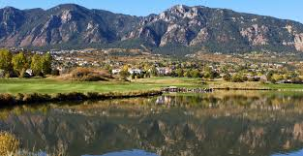

LAS VEGAS
The Strip provides some of the finest entertainment available. Unique performances like the Blue Man Group, Siegfried and Roy, Celine Dion, and others hold audiences captive. Clubs like Studio 54, House of Blues, Tangerine, The Beach, Curve, Lure, and many more stimulate the night life. Gaming is available at all hours of the day and night. Though the Strip is exciting and constantly buzzing with activity, it isn’t the only place in Vegas for entertainment. Station casinos throughout the valley provide state-of-the-art movie theaters, bowling alleys, clubs, and great eats. Speaking of food, Las Vegas hosts some of the finest dining available. Throughout the valley, you can find entrees of any style and origin of food.

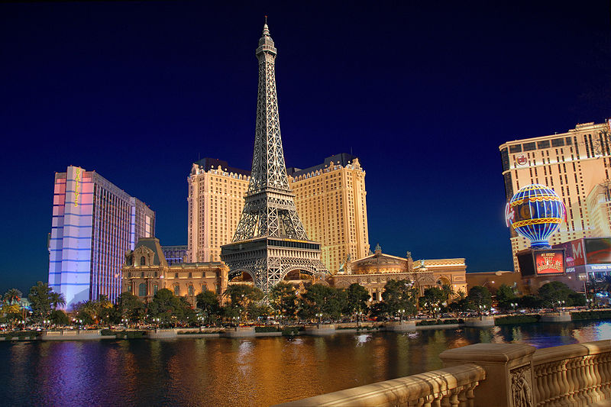
PARK CITY
The perfect mountain town. Combining its silver mining town heritage, an artistic vibe and a deep appreciation for the outdoors, Park City strikes a balance between luxury and comfort, all the while showing a deep appreciation for athletics, arts, and community. Whatever your daily activity may be, you’ll work up an appetite for the diversity of fine restaurants that line Park City's Historic Main Street and beyond, and you'll want to wind down after a long day with the craft whiskeys and vodkas at the High West Distillery and Saloon.
Any visit to Park City requires a leisurely walk down Historic Main Street. All year long, you can duck into the shops to browse, or grab a coffee at Atticus Bookstore and sit yourself down on a bench and soak in the sun and scenery. And the offerings of outdoor recreation are immense. Come summer, the winter slopes once featured in the Olympics and nearby state parks and reservoirs transform the landscape into a hiking, mountain biking, fishing, and camping mecca.
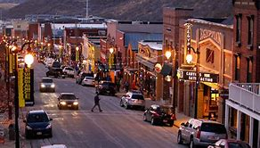

ST. GEORGE
Below the rim of the Great Basin sits Utah's warm-weather retreat, the town of St. George. The stunning valley combines transitional land features from the neighboring basin and Colorado Plateau with the landscapes and wildlife of the Mojave Desert. Red rock mesas and lush waterways create the setting for one of Utah's fastest-growing cities. Today, that growth and unique setting translate to family adventures, luxury spas, extensive shopping, championship golf and nearby outdoor recreation assets unlike anywhere else. In other words, fishing, climbing, canyoneering, biking, hiking, ATV and more — all in the unbeatable climate of beautiful St. George, Utah.
